
Revising the Select Query I

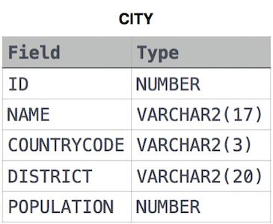
Query all columns for all American cities in CITY with populations larger than 100000 . The CountryCode for America is USA . Input Format The CITY table is described as follows:

Answer:

Below query works for
- Microsoft SQL Server
- mySQL
- Oracle

SELECT * FROM CITY WHERE COUNTRYCODE='USA' AND POPULATION >100000;

IBM DB2:

SELECT * FROM CITY c WHERE c.COUNTRYCODE='USA' AND c.POPULATION >100000;

